ASSIGNMENT 2 : DSA

**Question 1**

Write a program to print the following pattern

1

2*2

3*3*3

4*4*4*4

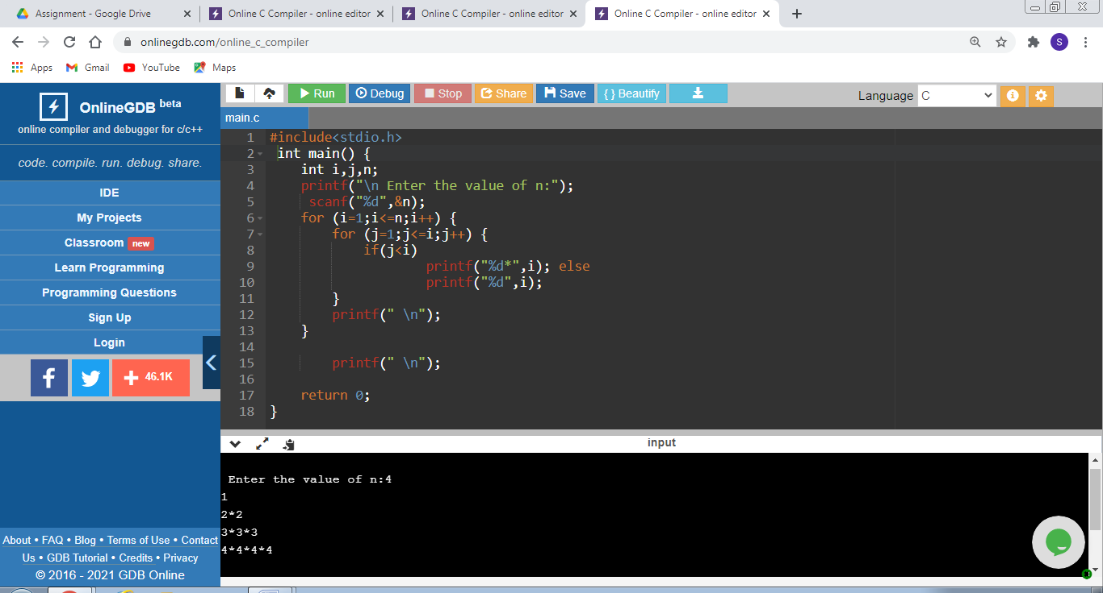

**Question 2**

Write a program to print the following pattern

1

01

101

0101

10101

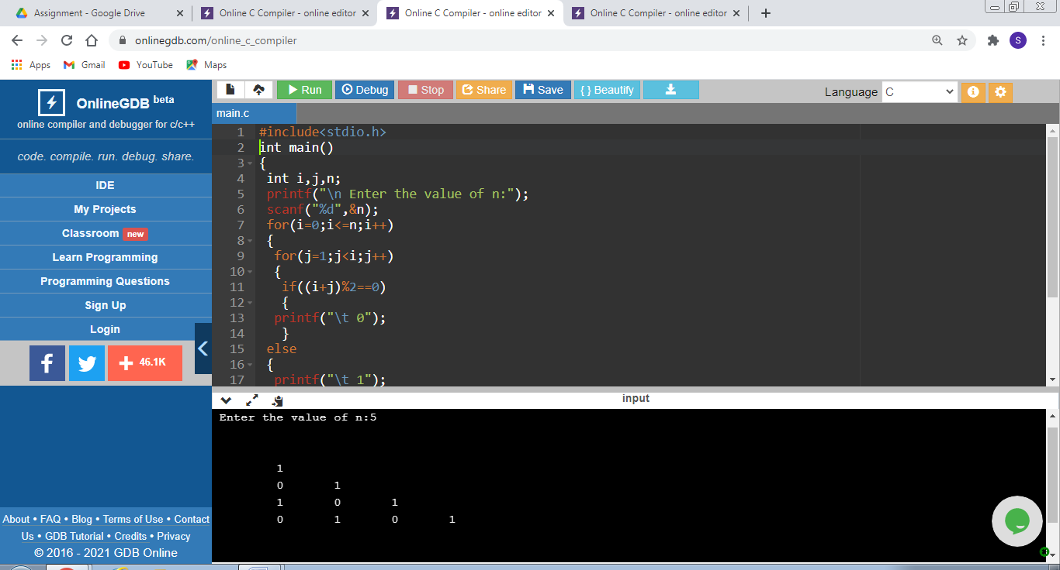

**Question 3**

Write the similarity and difference between an array name and a pointer variable.

**ARRAY :**

Array is used to store elements of same types.

**POINTER :**

Pointers are address varibles which stores the address of a variable.

**DIFFERENCE :::**

* Array variable cannot be assigned address of another variable but pointer can take it.
* **sizeof() operator** prints the size of array in case of array and in case of pointer, it prints the size of int.
* A normal array stores values of variable and pointer array stores the address of variables.
* An array can store the number of elements, mentioned in the size of array variable but A pointer variable can store the address of only one variable at a time.